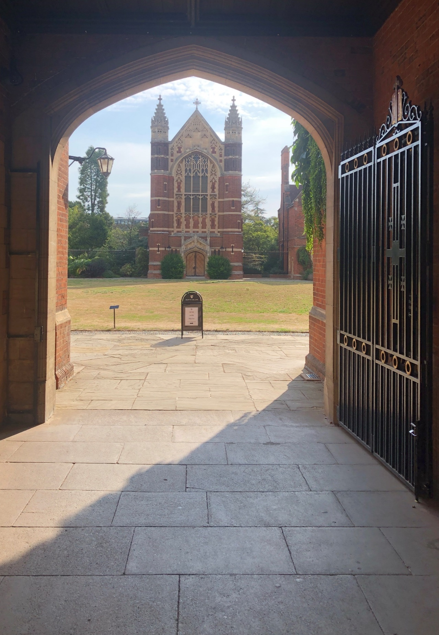
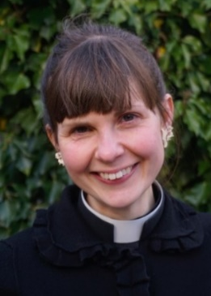
Welcome!
Welcome to Selwyn College and to Cambridge!
My name is Arabella, and I am the College Chaplain and Dean of Chapel. The information below will tell you a little more about me and what I do in college, and about the Chapel: why we have one, and what happens in and around it.
You will not know yet all that your time at College and University may bring in terms of challenge and opportunity. What I, and all those who help with pastoral care in college, do want you to know is that you are not alone through it all. I’m hugely glad to provide a confidential listening ear here in college for those of all faiths, of none, and everything in between. And to run Chapel as a place of peace and sanctuary, with beautiful services opening up the best of the Anglican Christian tradition in ways that we hope have integrity but also humility and openness.
An Introduction to Chaplaincy at Selwyn College, Cambridge
for undergraduates


It’s such a privilege to share the joys and sorrows of this community which you will soon be a part of. As you prepare to arrive, I will be holding your hopes, and your fears, on my heart.

Dean of Chapel and Chaplain
The Dean of Chapel and Chaplain is the Rev’d Dr Arabella Milbank Robinson. Arabella is a graduate of Oxford in English and French, with a PhD in Medieval Literature and an MPhil in Theology from Cambridge. She has been at Selwyn since 2022. She is a priest in the Church of England married to another priest, Jim, and they live in Grantchester with their two children, Aubrey (10) and Ivor (4), their new puppy, Pippin, and their longsuffering tabby cat, Grace.

As Dean of Chapel, Arabella has overall responsibility for the life of the Chapel. This includes services (in the Christian Anglican tradition but open to all) that take place across the term and across the year; the Organ Scholars and Chapel Choir (alongside the Director of Music, Sarah MacDonald); the Chapel Administrator, the team of student Chapel Wardens, Sacristans and other volunteers and the Gosden, Frost and Patteson scholars who are older or postgraduate students training to be Anglican clergy.
As Chaplain, Arabella’s pastoral care also extends to the whole College community, of all faiths and none. She tries to be present at all levels of college life and can offer support to students, Fellows and staff. She is a listening ear alongside the tutorial system, and will always observe appropriate boundaries of confidentiality. She is there for times of struggle and loss; she is there also to support and encourage people who are discerning dilemmas or issues in their lives, small and big, or with questions relating to their faith or spirituality. Her rooms in college are D7, Old Court, and you are welcome to visit at any time or arrange a coffee out of college. Just knock or email (amm245@cam.ac.uk or chaplain@sel.cam.ac.uk). She is usually out of college on a Saturday, and at Newnham where she is also Chaplain on a Friday afternoon. In an emergency, the Porters’ Lodge will be able to make contact.
Alongside Lucy Turnell, the College Nurse and Wellbeing lead, Arabella also works to foster a culture of mutual flourishing within the college. They host creative workshops, Wednesday walks, and trips in and around Cambridge to which all are welcome.
When you arrive at Selwyn, you’ll be asked to a brief individual meeting with the Chaplain during your first week or so. Please do come along! Getting to know you is what the Chaplain is there for, whatever your religious affiliation or spirituality.

The Chapel

Selwyn College was founded in 1882 through donations made in memory of the first Bishop of New Zealand and Melanesia, George Augustus Selwyn, whose portrait gazes down on us all in the Dining Hall. Selwyn’s episcopacy was part of the complex connection between our global legacy as a colonizing nation and the history of the Anglican Church. However this is not just a story of complicity: Selwyn was for his time a very strong advocate of indigenous rights, language and culture, and impressive in the physical, intellectual and emotional effort he made in his work in the Pacific.

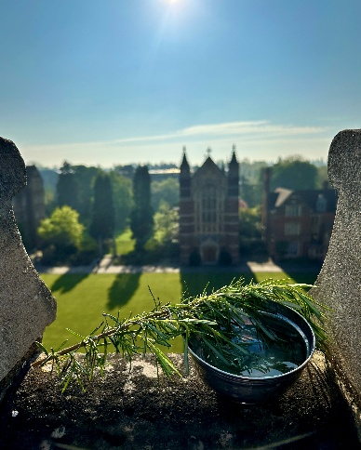
The college was founded ‘on the broad but definite basis of the Church of England…that its aim should be to encourage habits of simple living, and to develop the Christian character in its students’. Of course some things have changed! We are now a community enriched by its representation of all global faith traditions, and certainly not restricted to one gender. But what we inherit contributes to who we are, and forms us in a living tradition. Selwyn College owes to its origins its mission to widen access to a university education, a mission which goes from strength to strength, and it remains a community built on substantial values and the pursuit of the common good. The Chapel, consecrated in 1895, stands as a clear reminder of the continuing importance of the mystery and depth of faith and its contribution to our identities, fears and hopes; our vision and our projects. It is a Christian Anglican Chapel, and keeps deep and joyful faith with that tradition and its gifts, whilst also welcoming, hosting and celebrating Selwyn’s present diverse community of people of all faiths and none for college occasions of all kinds.
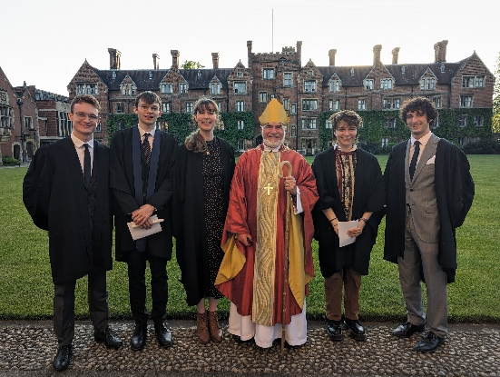
Your Chapel is open from 7am to midnight every day. Please do use it for retreat and reflection; there is always somewhere to light a candle and leave a prayer. You can join me most mornings for a short service of Morning Prayer in our special Upper Chapel Tuesday-Friday during Full Term at 8.45am (8am on Fridays, alternately with the Selwyn and Newnham Christian Union). Choral Evensong is sung by the Chapel Choir on Tuesday and Thursday evenings at 6.15pm. On Sunday, an intimate College Communion is at 10.30am, finishing in time for Brunch in Hall, and we come together for Sunday Evensong at 6pm with a visiting preacher, followed by drinks for all and the opportunity for anyone (and their guests) to book in for Sunday Supper in the Harrison Room above the College Bar. Watch out for twice-termly enchantingly candle-lit Choral Compline, and invitations to Remembrance, Advent and Christmas Carol services and other specials through the year. In Lent Term we will have a Baptism and Confirmation service for anyone who wants to affirm their Christian faith. In Easter Vacation there’s a Chapel Retreat at beautiful Launde Abbey. First years are especially invited to start the term with their Freshers’ Welcome Evensong at 5.30pm on Sunday 5 October.
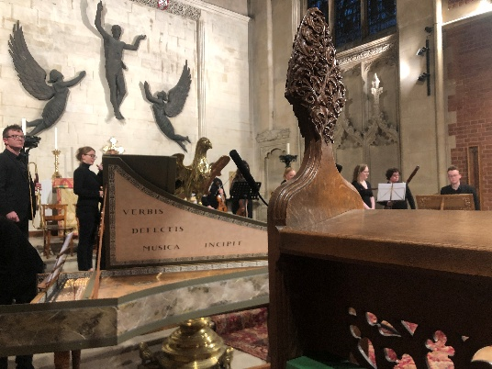
The Chapel Choir maintains a very high standard of singing. They tour internationally every summer and receive free singing lessons amongst other advantages. To ask more or audition, please contact the Director of Music, Sarah MacDonald on 01223 335877 or seam100@cam.ac.uk.
We can’t do anything without our student team! You are so very much encouraged to ask about participating in Chapel life: we need readers for the two readings at every Evensong, people to welcome at, set up for, and help with services (who get free Brunch or Chapel Supper on Sundays!), student preachers and help with the livestream. Please get in touch at amm245@cam.ac.uk or chapel-administrator@sel.cam.ac.uk (Rebecca Wilson) if you’d like to know more! www.sel.cam.ac.uk/about/chapel-and-choir
www.youtube.com/@SelwynCollegeChapel

